www.letsgosew.com

Zipper instructions as shown in the video for It’s Sew Easy TV show 2108-1

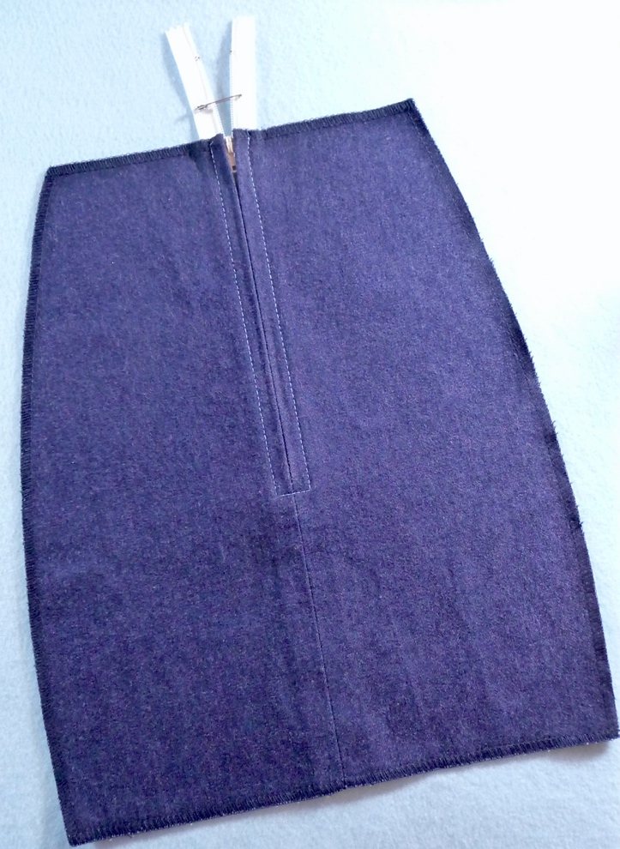

Slotted zipper steps, shown in video with time stamp as follows:
2:36 to 10:42

- Interface zipper area with one-inch strips of lightweight fusible interfacing. Start with zipper longer than required length.

- Mark needed zipper length at the top. Lay zipper along seam and mark the point of the stopper.

- Using standard sewing foot, sew 5/8-inch seam from bottom of seam to stopper, backstitching at beginning and end. Stop where you are and change stitch length to basting length. Finish sewing seam, leaving a tail of thread at the end. Press seam open.

- Open zipper and lay one side of zipper coils directly along the seamline, with coils just touching the closed seam. Repeat for opposite side of zipper cols.

- Baste in place by hand or secure with ¼-inch wash away tape. Flip to the right side and mark fabric just below the stopper. Next, mark the top stitch line for the slotted zipper, marking straight lines approximately ¼-inch from the closed seam.

- Once you have the zipper basted in place, it’s time to topstitch from the right side. Attach zipper foot to machine. You can use a snap on zipper foot, adjustable zipper & piping foot, or narrow base zipper foot. Note that the standard foot with the grooves is designed to sew this type of zipper with the groove in the foot riding over the bulk of the coils. Pivot to stitch both sides of the zipper or just sew one side and the bottom line, then pull threads to wrong side, tie off the threads by hand, and sew second side of zipper from top to bottom, using opposite side of foot.

Notes:

