www.letsgosew.com

Zipper instructions as shown in the video for It’s Sew Easy TV show 2108-1

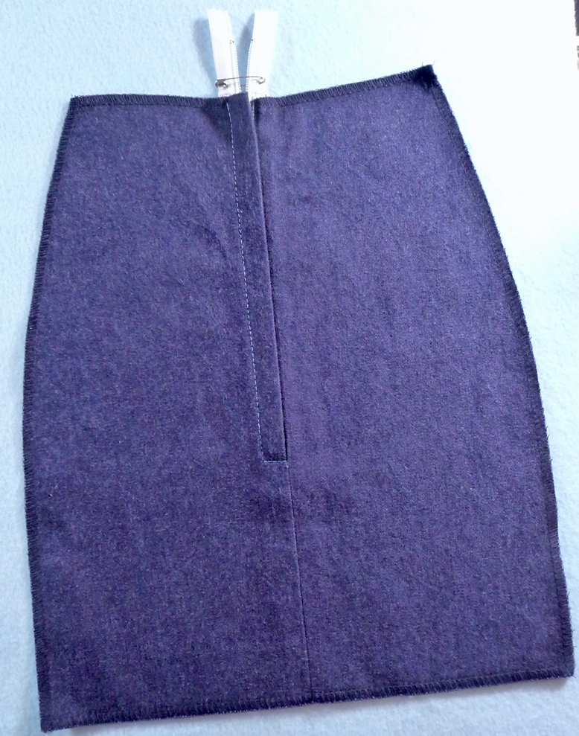

Lapped Zipper steps, shown in video with time stamp as follows:
10:42 to 13:46

- Complete steps 1-3 as described for slotted zipper.

- Lay skirt flat, with both skirt fabric pieces right sides together, and skirt layers pushed toward the right-hand side. Open zipper all the way. Lay zipper face down on the open seam. Baste zipper tape to the single layer of the seam allowance with coils just touching the closed seam. Next, sew close to zipper teeth with groove of foot riding over coils, backstitching at the end.

- Close zipper. Roll zipper to the left so right side of zipper is facing up, with a small extension of fabric to the right of the zipper coils. Topstitch close to zipper coils, stitching along the extension with groove of foot riding along zipper coils. Note that you need to stitch through just the fold and the previously stitched zipper tape.

- Open pieces out flat with wrong side of garment pieces facing you. Note that a small pleat will form near the zipper stop at the bottom. Change to basting stitch in center needle position.

- Working from the wrong side, baste through the zipper tape and the garment fabric, beginning just below the bottom zipper stop, and sewing with the grove of the foot riding along zipper coils.

- To finish, topstitch from the right side, using the previously basted line as a guide, and pivoting at the bottom, just below the bottom zipper stop. Remove basting stitches.

Notes:

